**sdg_index_score and goal_1_score by goal_1_score**

**Analysis On Overall Sustainability On No Poverty**

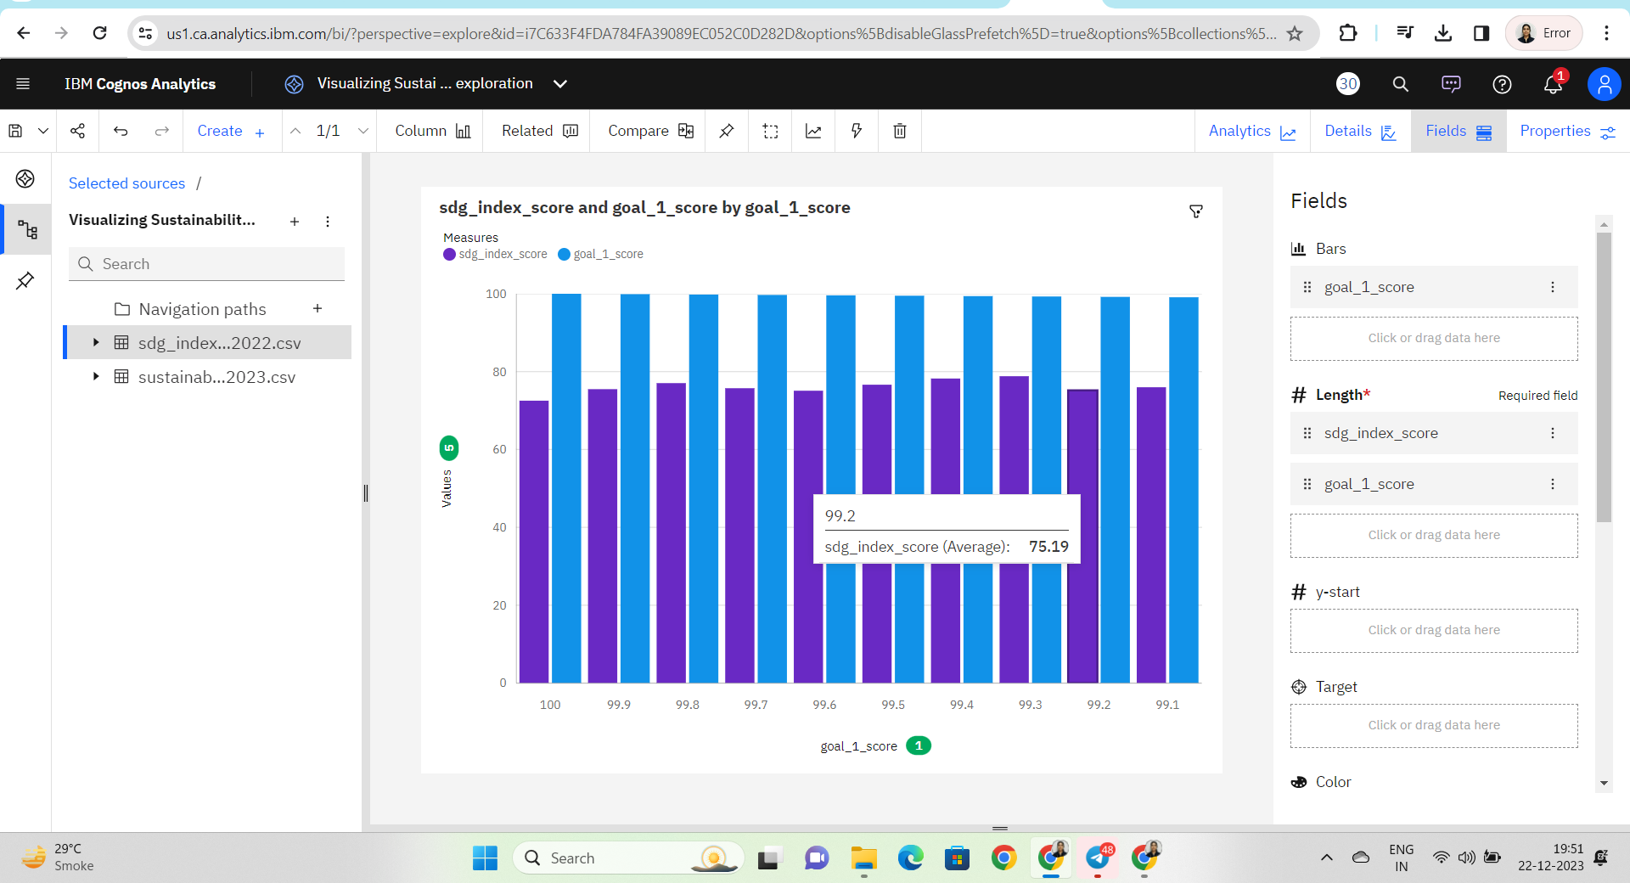

**Analysis overall sustainability on Quality Education**

**goal_4_score and goal_14_score by country**

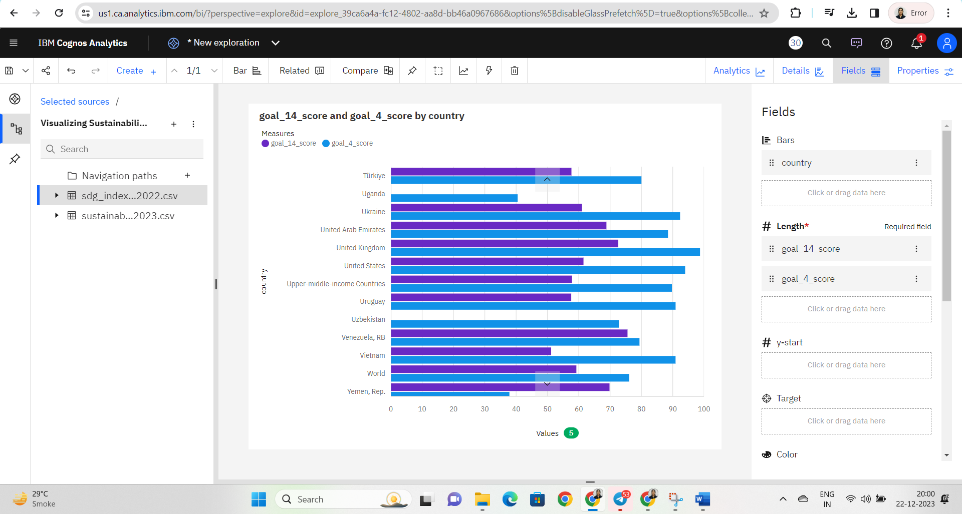

### Analysis On Overall Sustainability Life Below Water

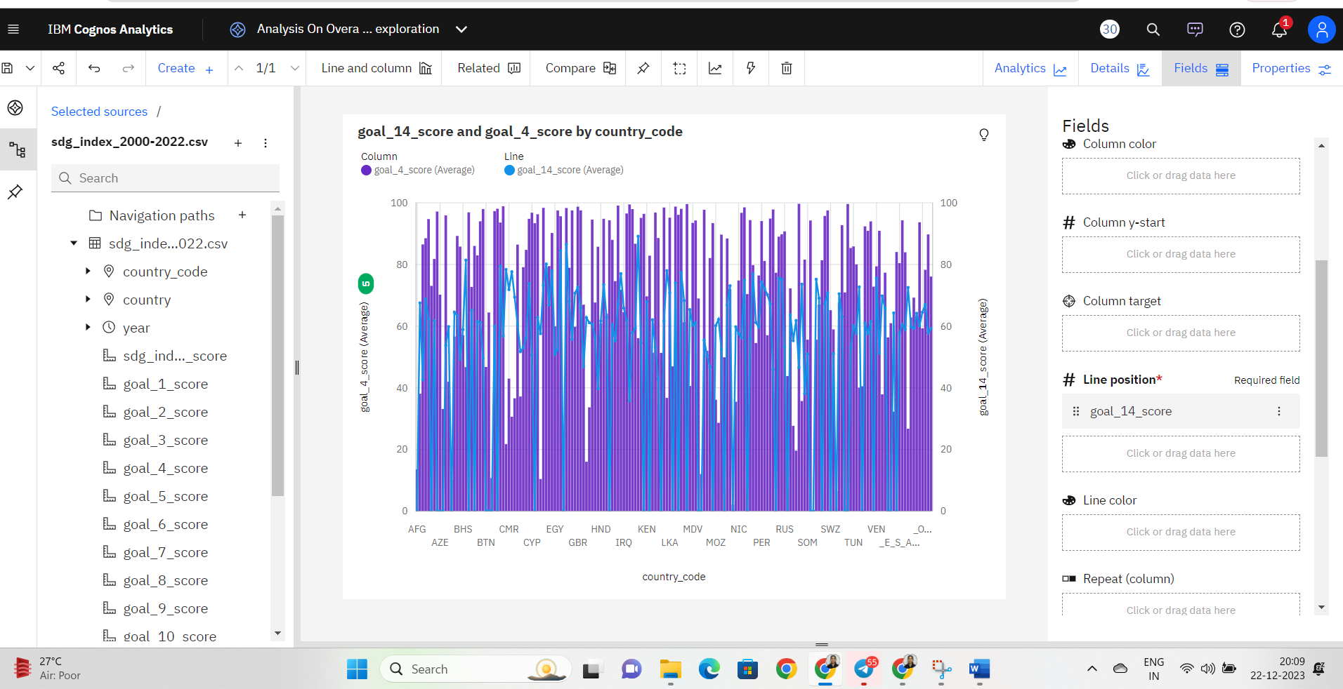

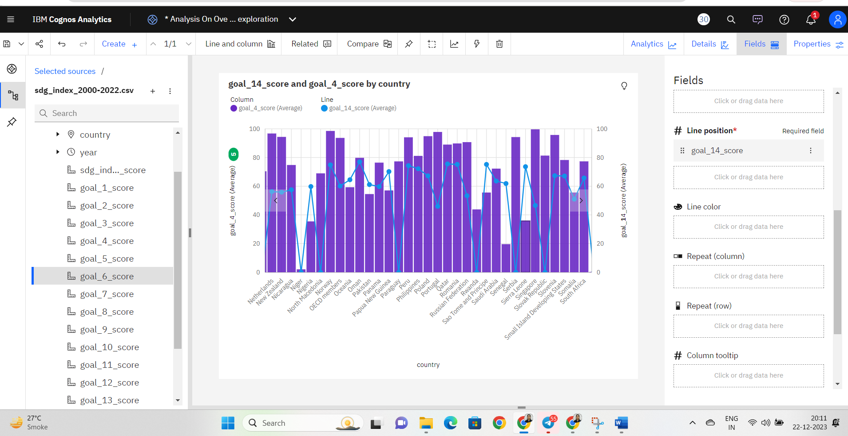

### Analysis On Overall Sustainability Partnerships For The Goals

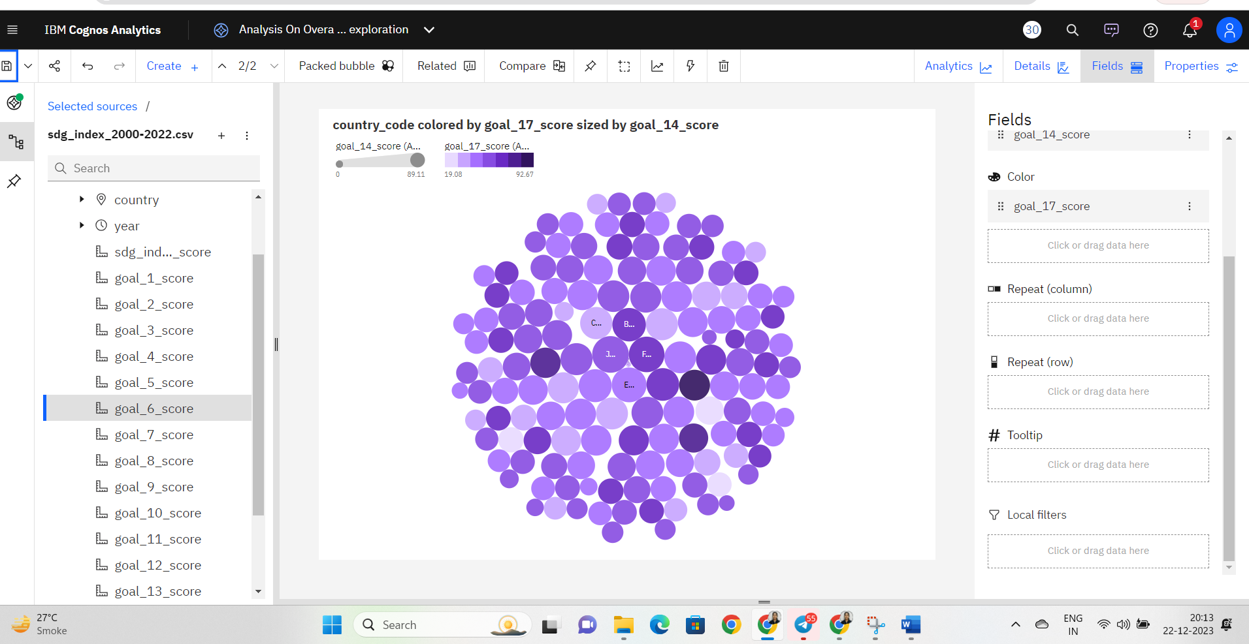

### Analysis On Overall Sustainability Reduced Inequalities

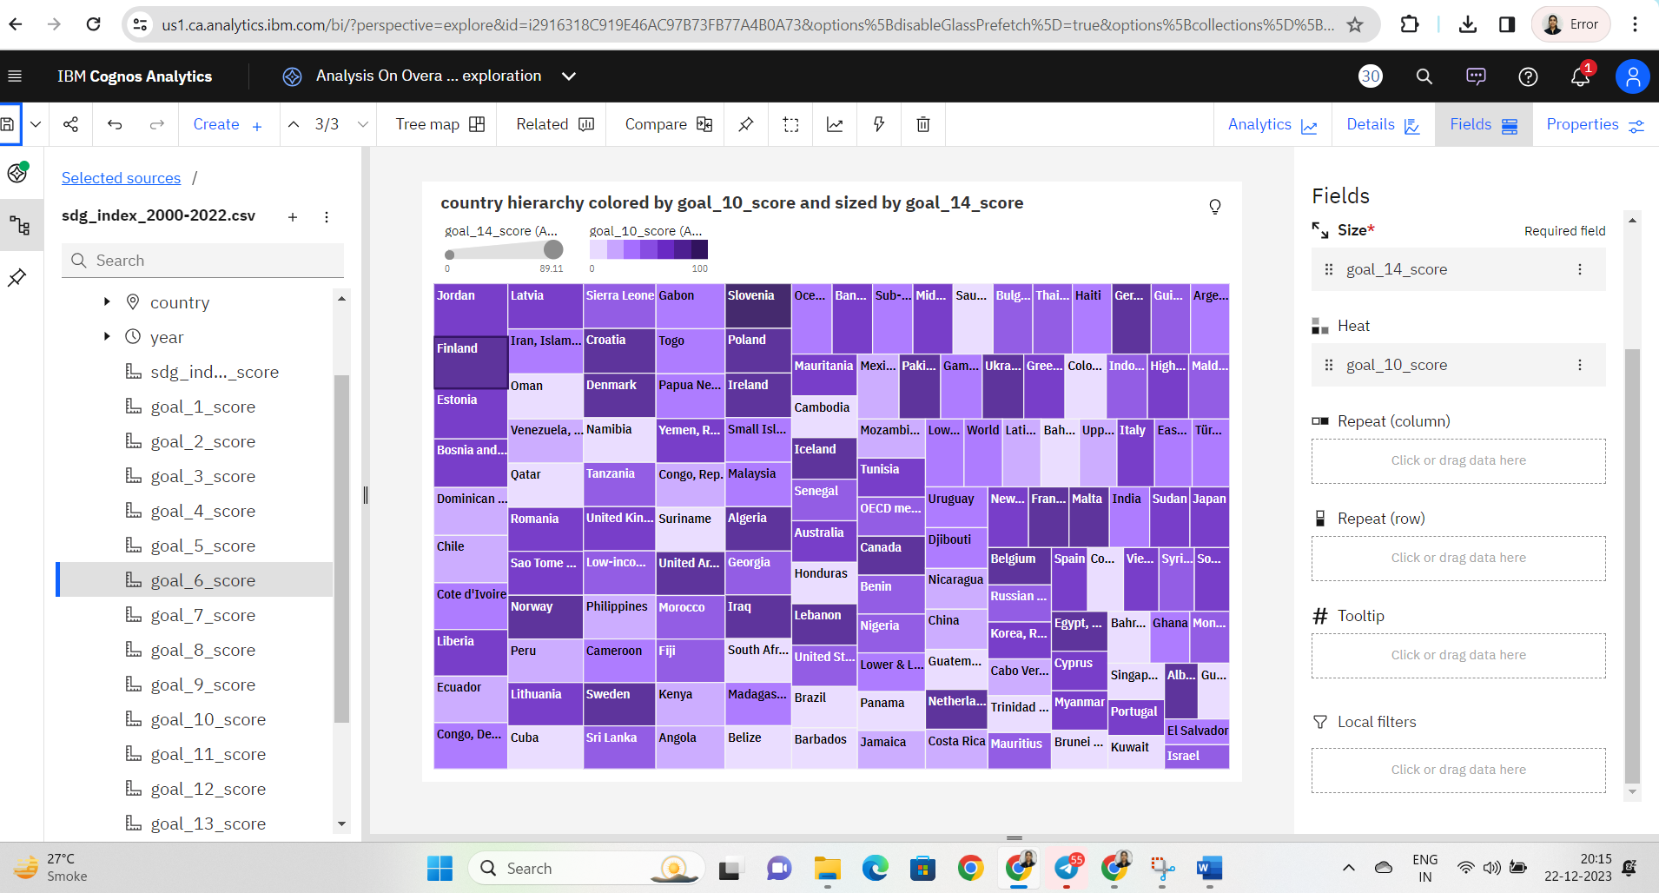

### Analysis On Overall Sustainability Industry, Innovation And Infrastructure

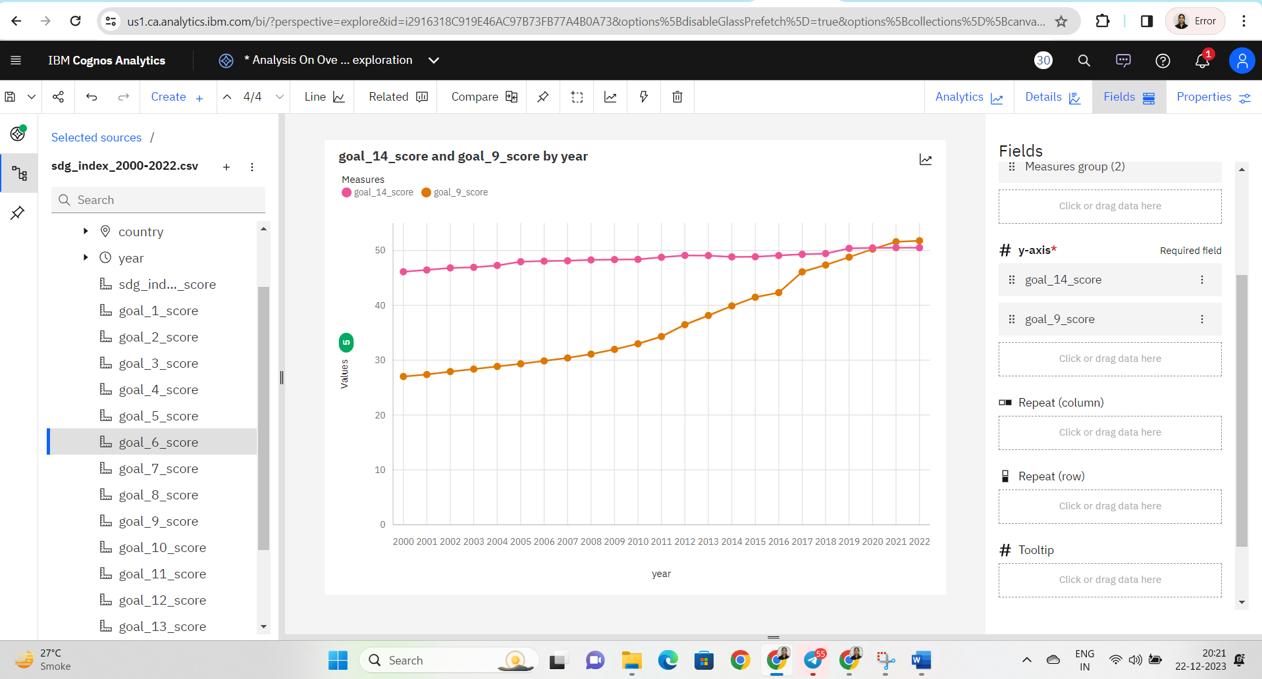

### Analysis On Overall Sustainability Life On Land

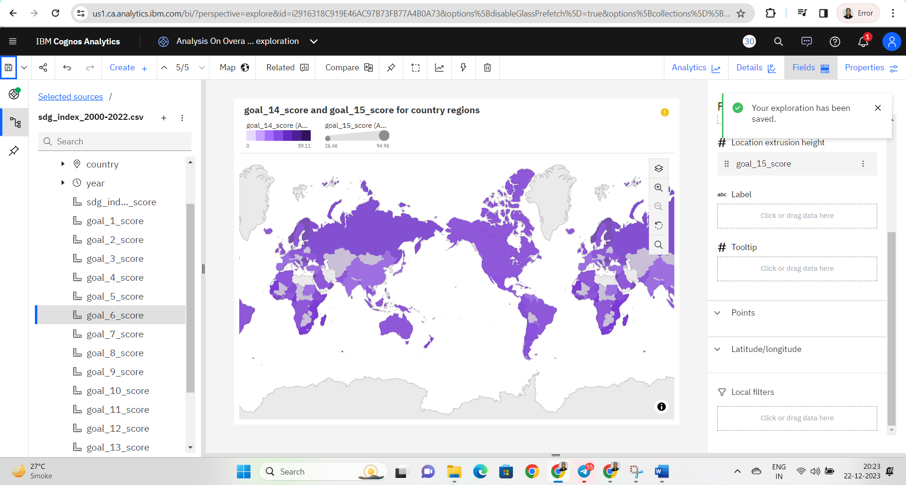

### Dashboard

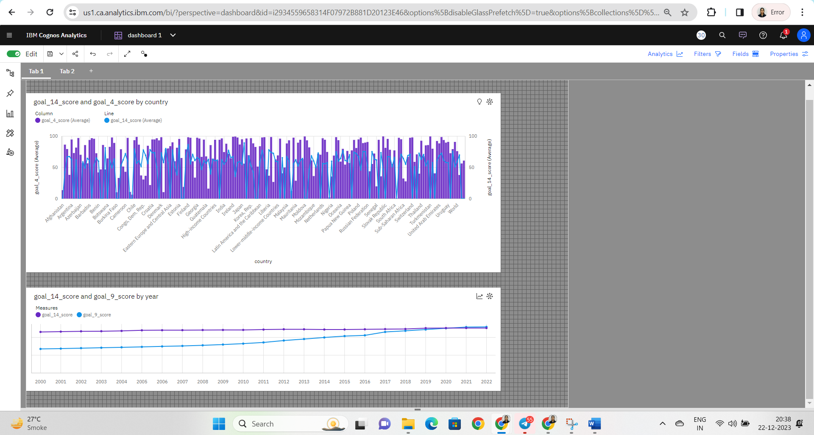

**Dashboard 2**

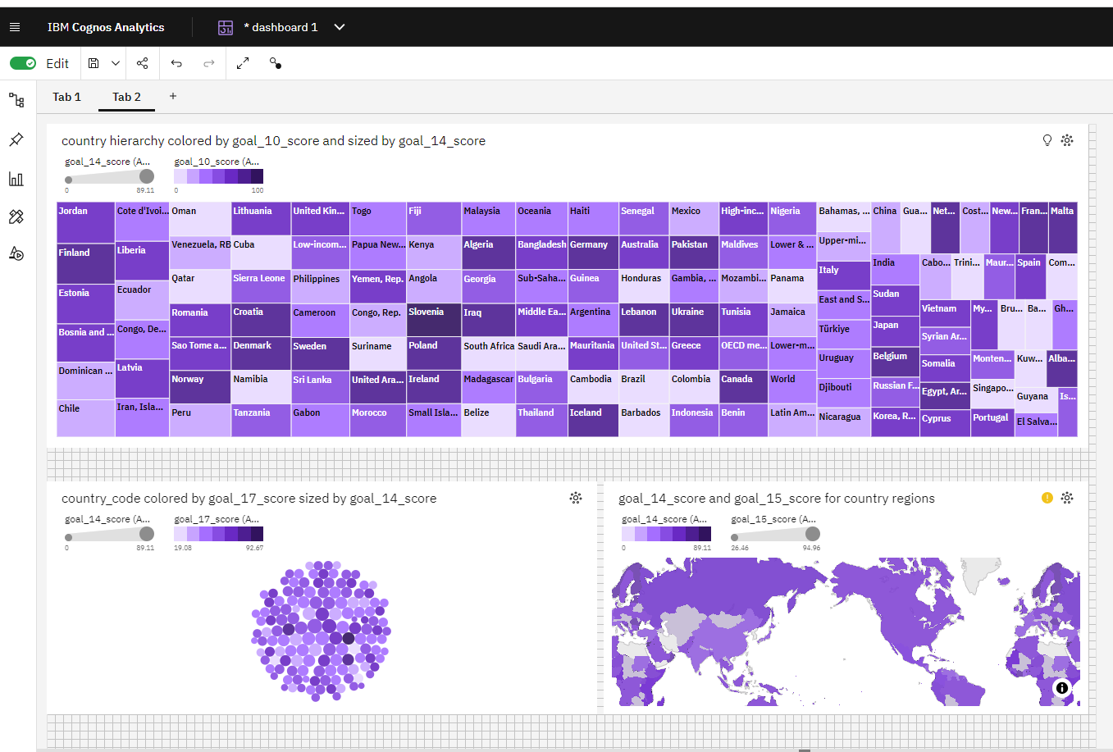

### No Of Scenes Of Story

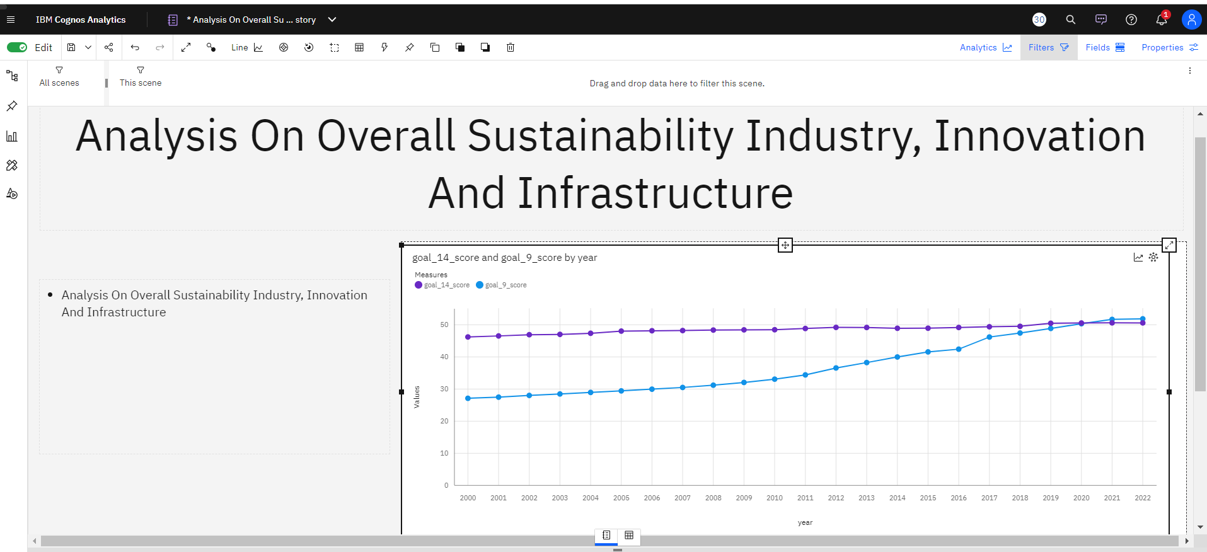

* Analysis On Overall Sustainability Life Below Water

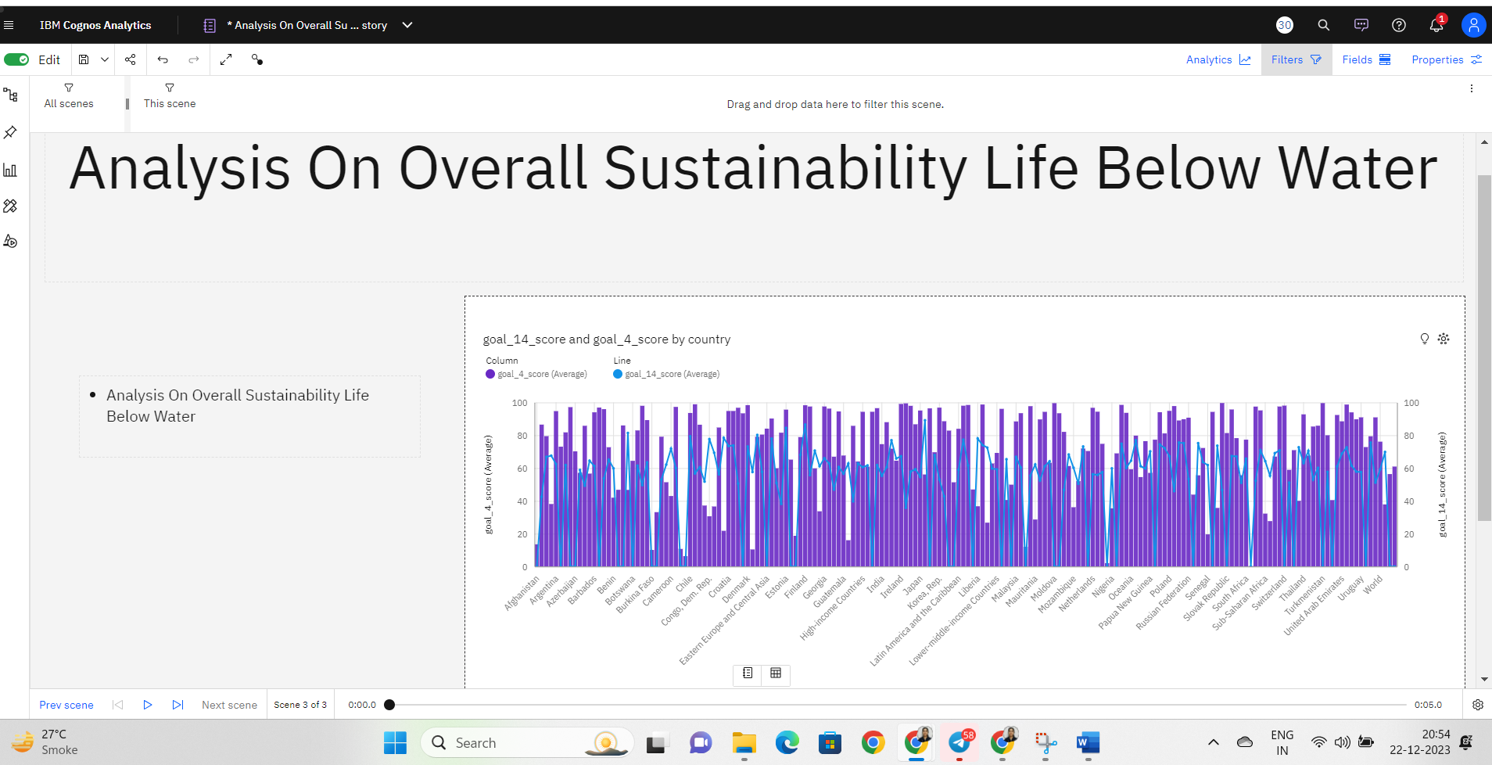

### Creating A Report

Activity 1: Creating a report

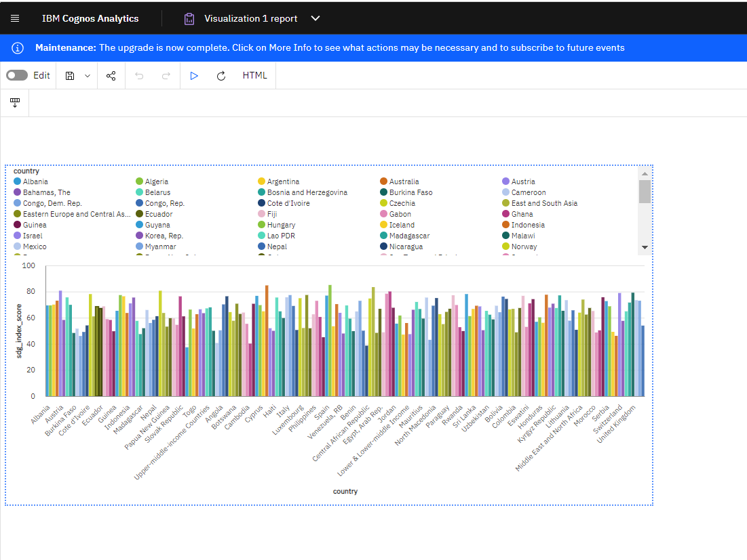

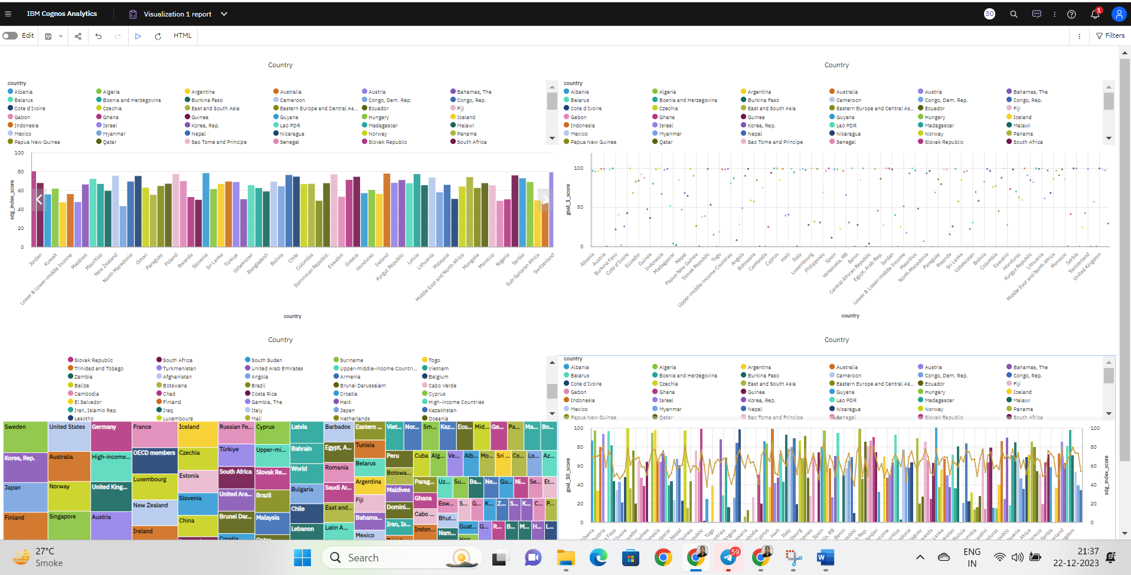

### Performance Testing

**Activity 1: Utilization of Data Filters**

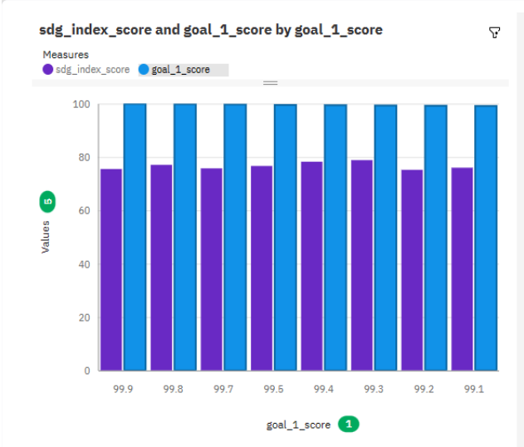

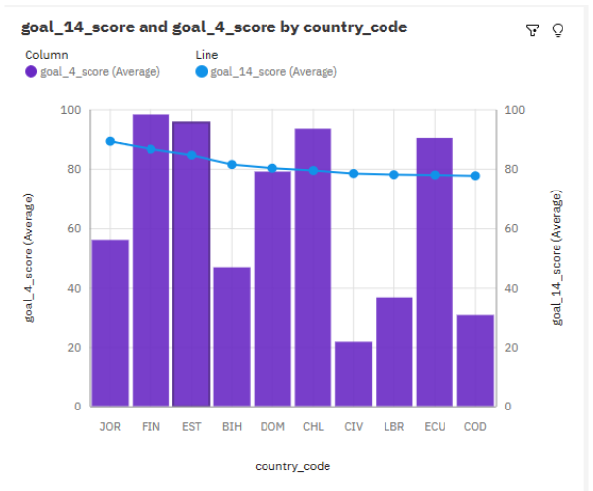

### No Of Calculation Fields

### 

### Dashboard And Story Embed With UI With Flask

**Activity 1: Dashboard and Story embed with UI With Flask**







